Clinical Documentation - Herz Lab

1. General Overview 3
1.1. What is the role of a Clinical Specialist? 3
2. Hardware 4
2.1. System 4.0 Hardware Flowcharts 4
2.2. System 4.0 Equipment List 5
2.3. Images of Individual Components 6
3. Task Laptop Setup 7
3.1. Desktop Organization 7
3.2. Desktop Config File Settings 7
4. Before Running a Task 8
4.1. Consenting / Meeting the Patient 8
4.2. Creating a REDCap Entry 8
4.3. Imaging 8
4.3.1. ITK-SNAP 8
4.4. Docs generation (Jacksheet, Area File, Mono- and Bi-polar Montages) 8
4.4.1. Jacksheet 8
4.4.2. Area file 9
4.4.3. Stim file 10
4.4.4. Monopolar vs bipolar montages 11
4.5. Identify Bad Channels, seizure onset zone 12
4.6. Checklist to avoid errors / Troubleshooting 12
5. Stimulation Safety Testing 14
6. Saving the Data 15
6.1. Folder organization 15
7. Post-Processing 16
7.1. Annotations 16
7.2. Initial Data Report 16
7.3. Voxtool 16
8. Additional Information 17
9. Additional Resources 18

1. General Overview

1.1. What is the role of a Clinical Specialist?
- Hospital Testing
  - At Jefferson Hospital for Neuroscience (900 Walnut Street), we conduct testing of memory-related experiments on neurosurgical patients in the Epilepsy Monitoring Unit (EMU, 7th floor).
    - The patients who have medically-resistant epilepsy are implanted with intracranial electrodes to monitor brain activity. The hospital’s goal is to understand where the seizures originate in order to inform further treatment.
    - Patients are explanted (i.e., their electrodes are removed) some time after they have seizures. They can stay anywhere from several days to a few weeks—this can be difficult to predict. Thus, it is paramount to try to test patients as soon as possible.
  - We can record the brain activity from the patients’ intracranial electrodes while they complete memory tasks. Your job involves running experiments with patients when they are in the hospital.
- Data Processing
  - It is your job to process data once it has been collected and make sure it is ready to analyze.
- Clinical Management
  - Train future clinical specialists and volunteers, streamline or improve our existing processes.
- Research Project
  - Clinical research specialists may have an independent research project.

2. Hardware

2.1. System 4.0 Hardware Flowcharts
System 4.0 testing refers to the method of testing, which includes using custom splitter cables to interface directly between the clinical acquisition system and the Blackrock system. This is an updated version of the system 2.0 setup. Blackrock equipment is built into a mobile cart with capability to record from 256 channels at once using lab-generated software, Elemem.

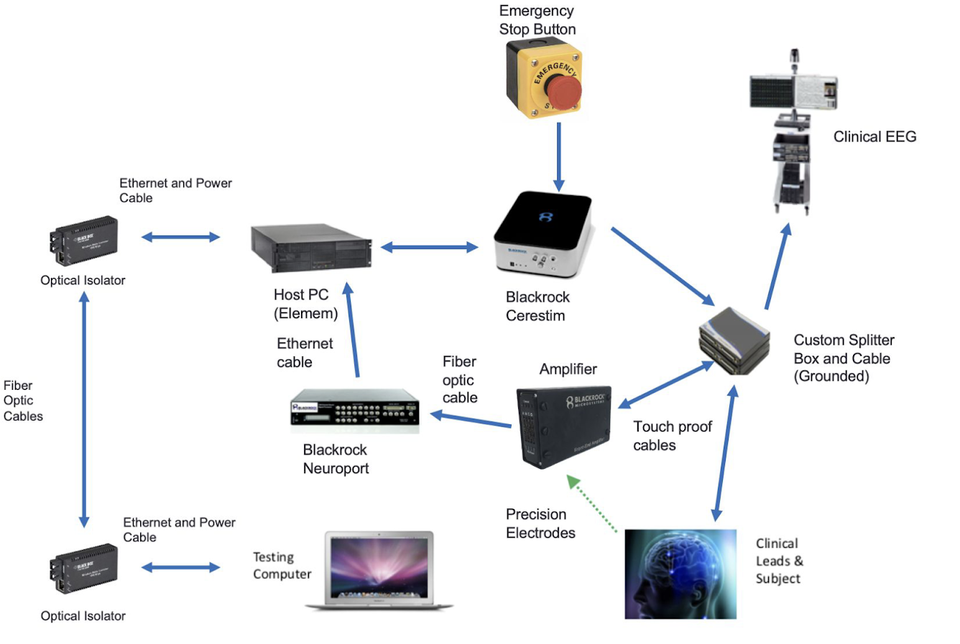

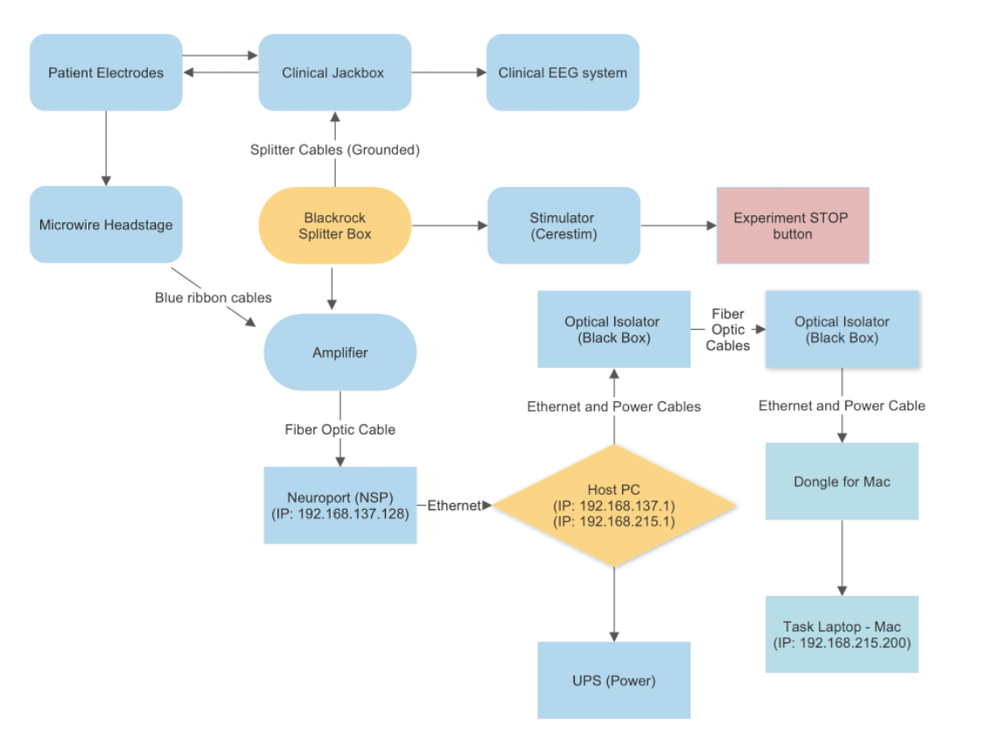

2.2. System 4.0 Equipment List
- Blackrock cart
  - Power strips on Blackrock cart (2)
  - Power extension cord
  - UPS
- Elemem host PC
  - Computer monitor
  - VGA cable
  - Power cable
- Task laptop
  - Ethernet adapter (with USB port if necessary)
  - Charger
  - Game controller for tasks
- Flash drive
- Optical isolator (2)
  - Ethernet cable (2)
  - USB power cords (2)
  - Fiber optic cables (2)
  - TP-LINK 5-Port Gigabit Desktop Switch
  - Ethernet cable from network switch to host PC optical isolator
- Neural Signal Processor (NSP)
  - Ethernet cable from host PC to NSP
- NeuroPort Neural Signal Amplifier (2)
  - Amplifier power supply cables (2)
  - Blue ribbon cables from Cerestim to amplifier (3)
- Fiber optic cables from amplifier to NSP (2)
- Cerestim
  - Emergency stop button
  - Emergency stop cable
- Splitter boxes (4)
  - Blue ribbon cables from amplifier to splitter boxes (8)
  - Custom touchproof splitter box cables (8)
- Microwires
  - Butterfly adapter

2.3. Images of Individual Components
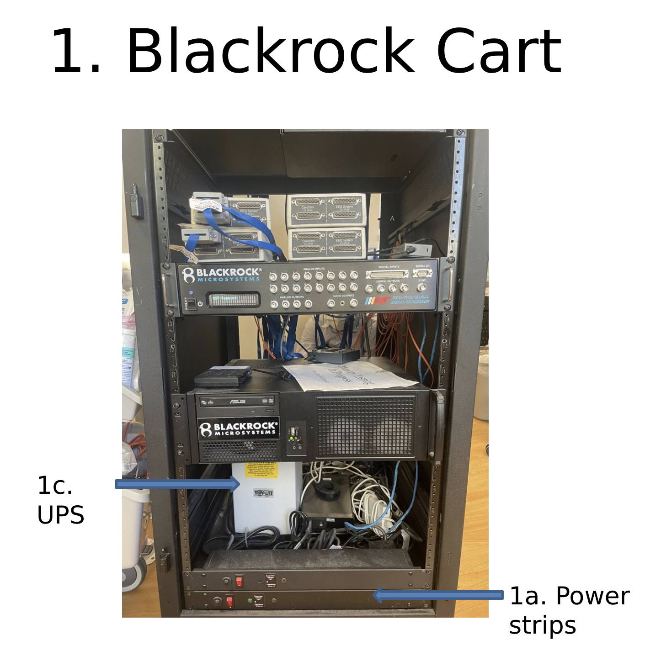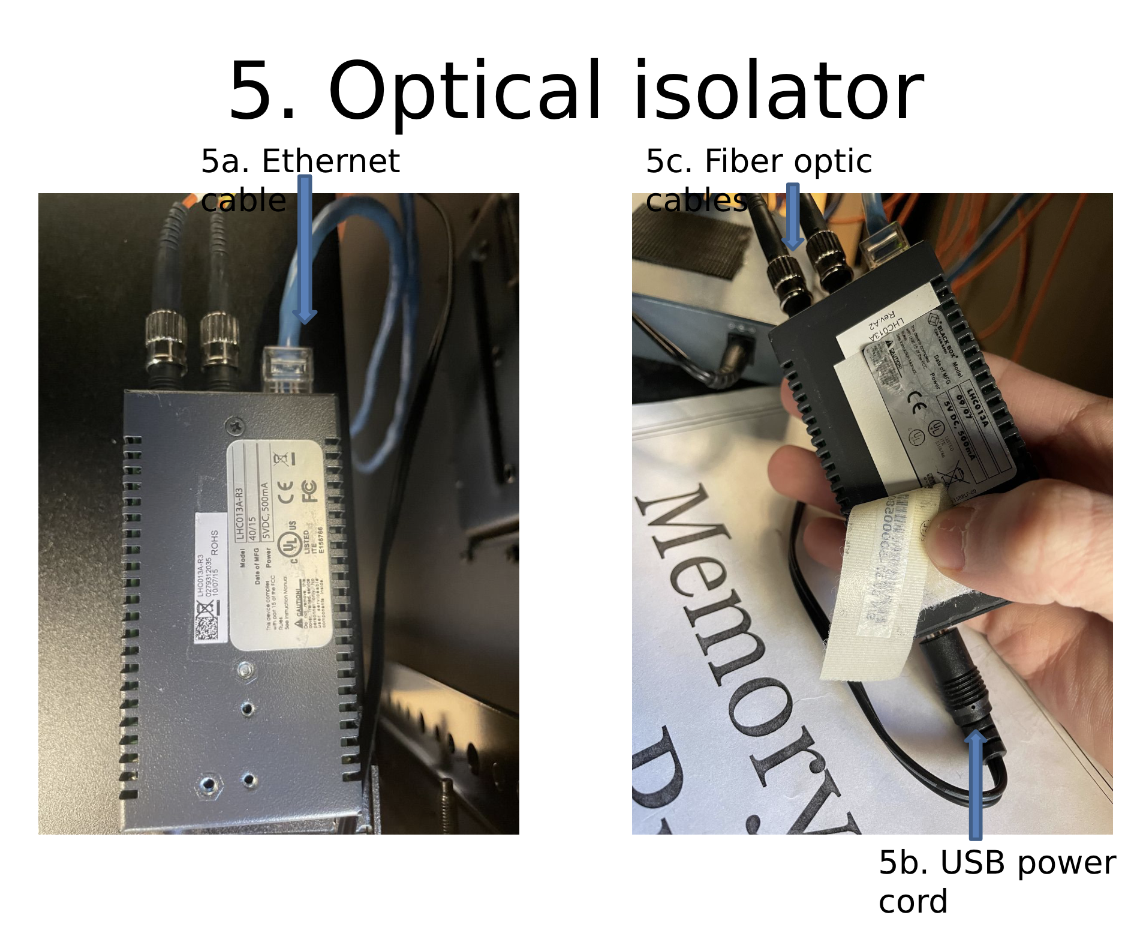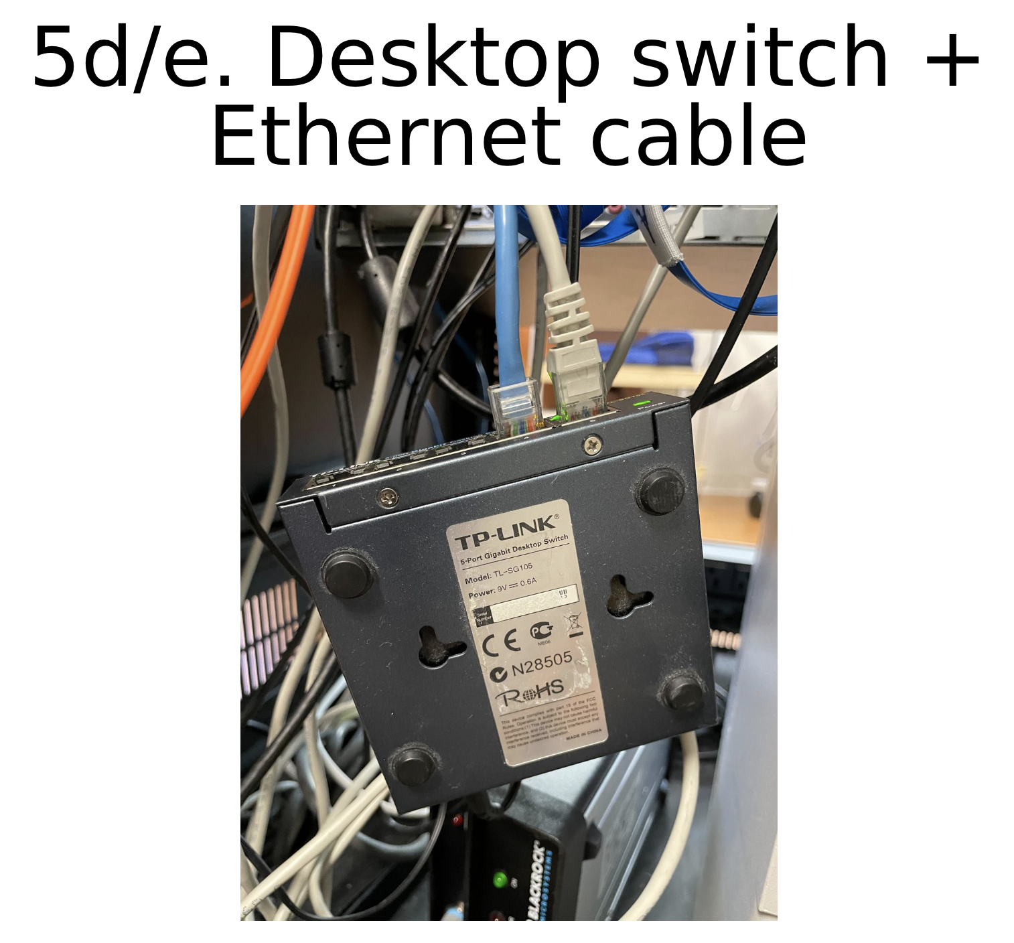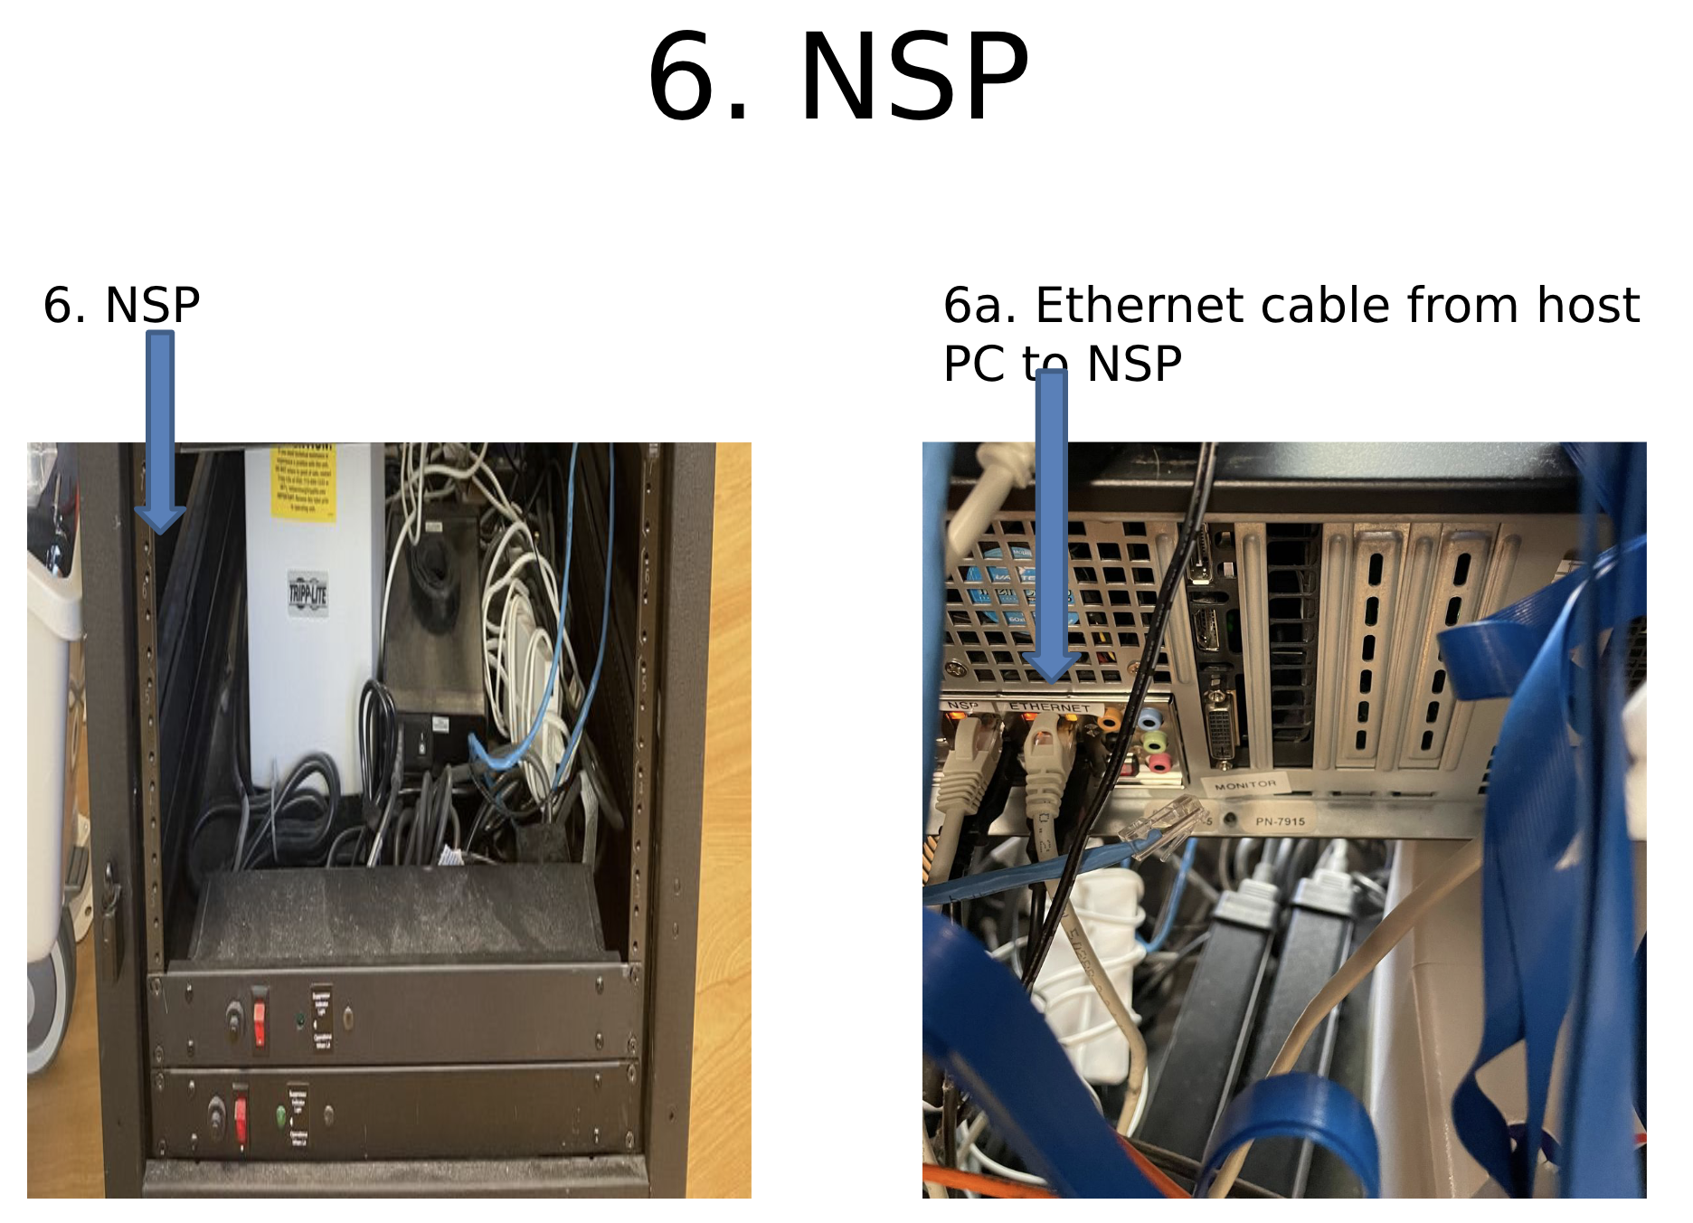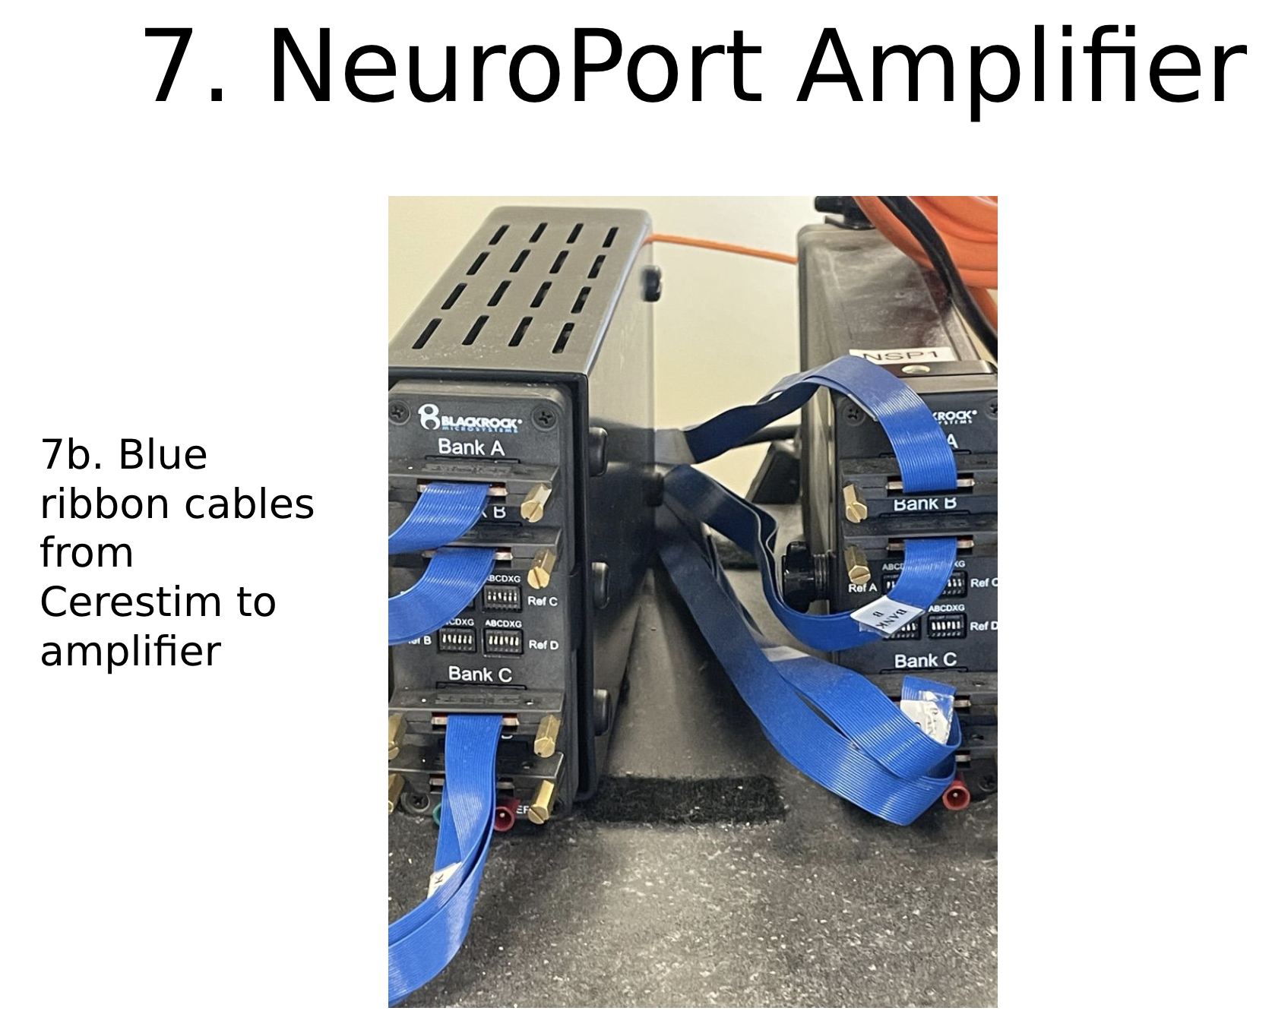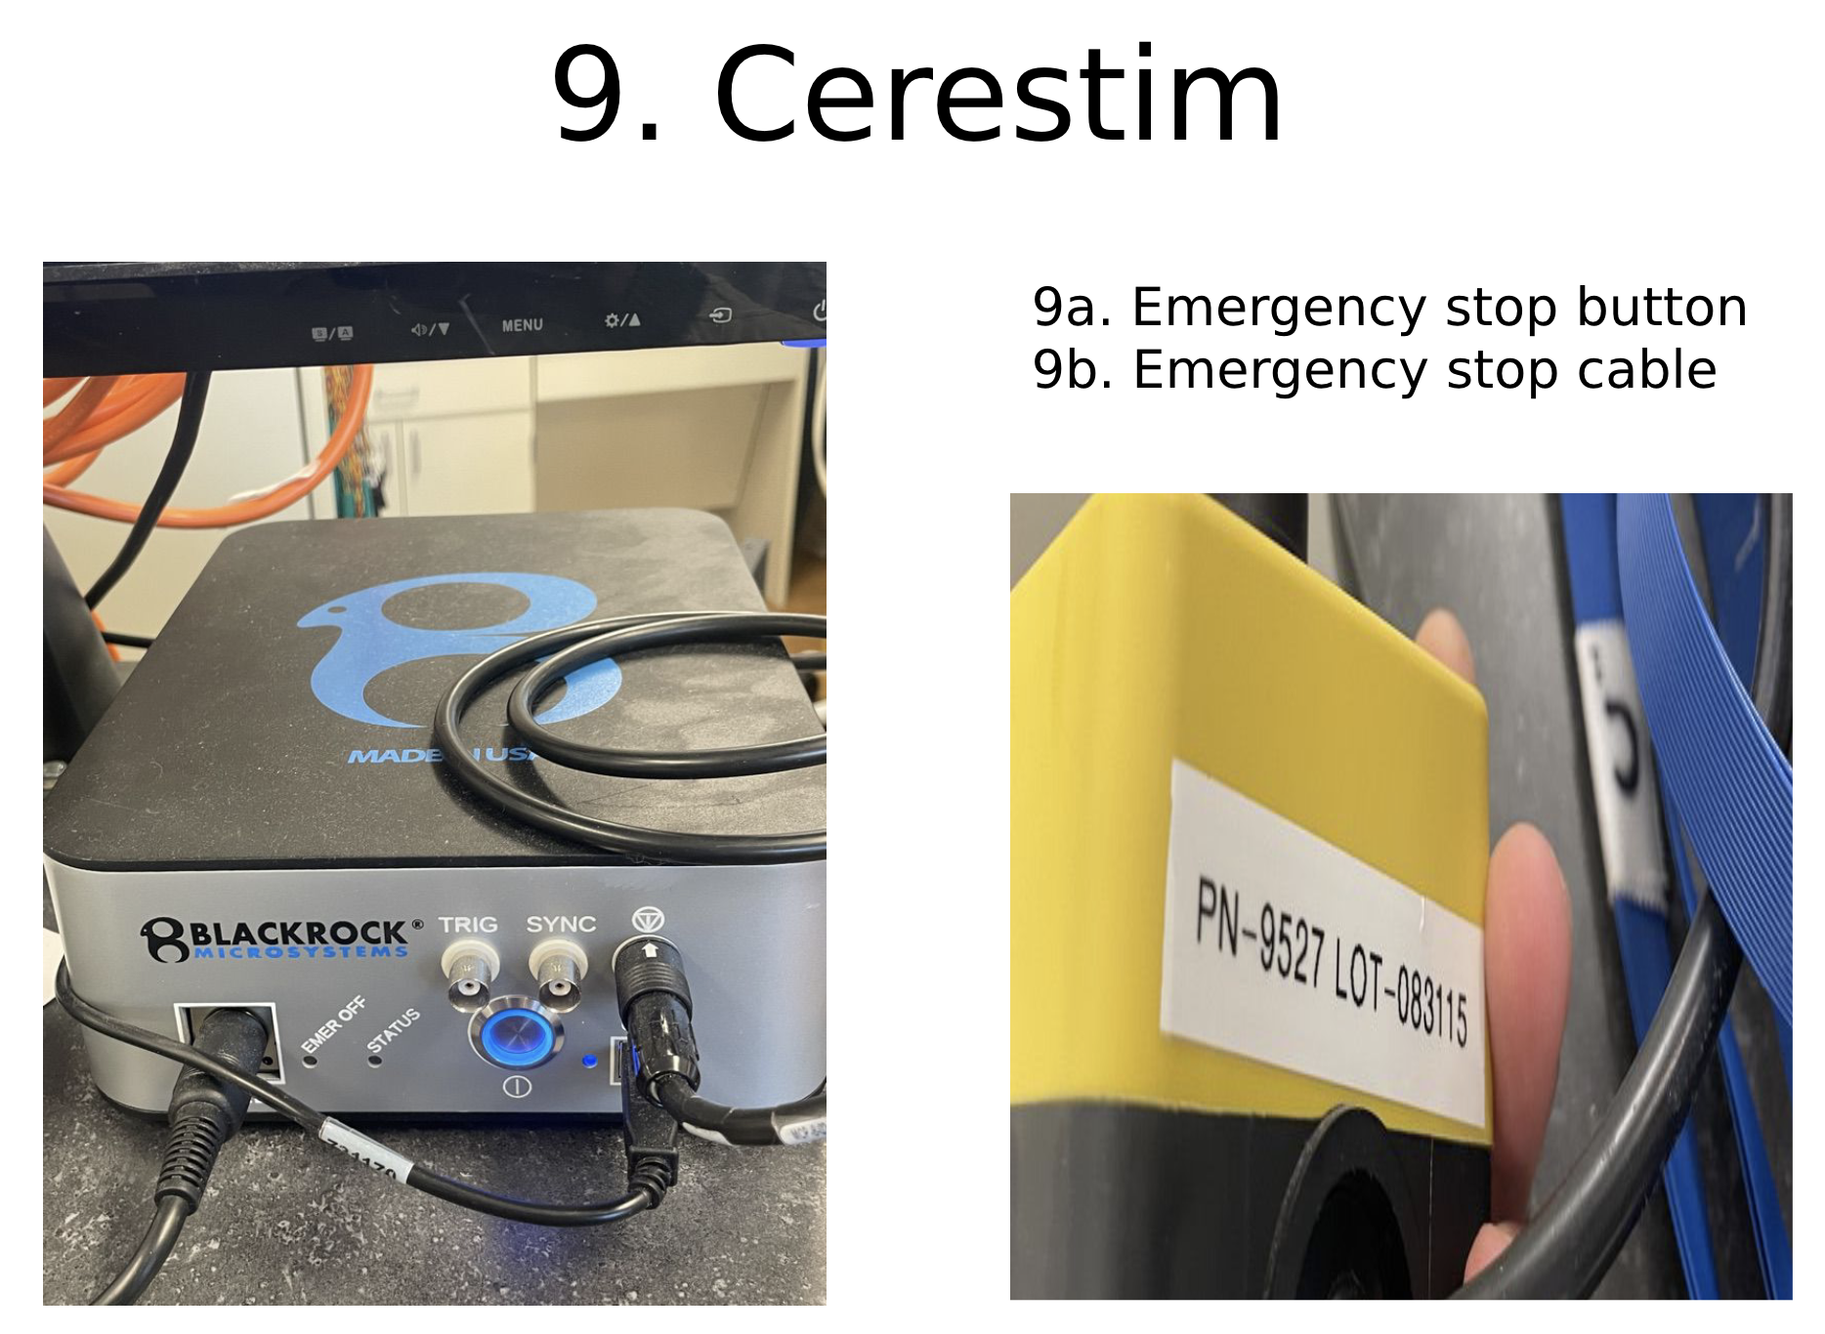
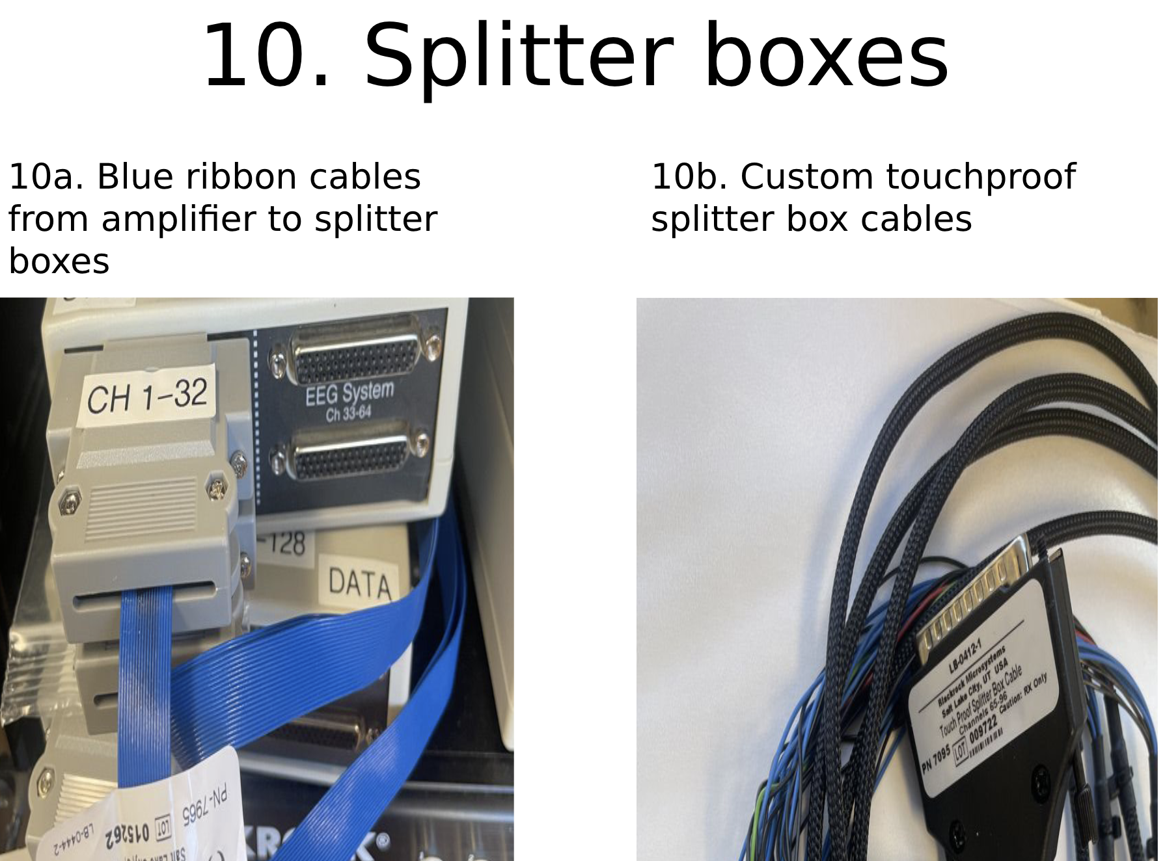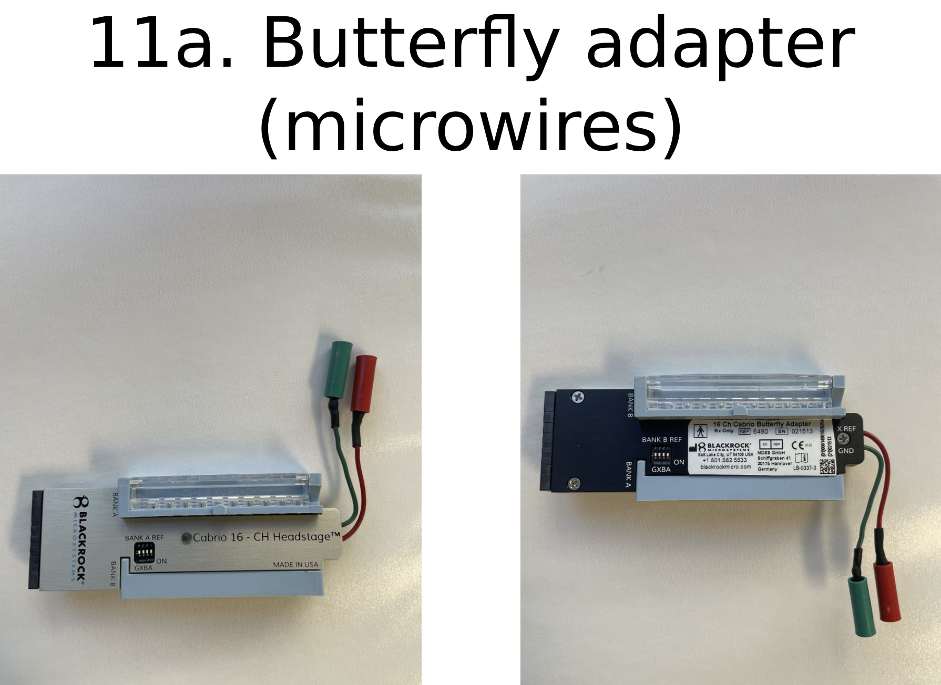

3. Task Laptop Setup

3.1. Desktop Organization
- Memory-Mapping Task build
- ‘Data’ folder
- ‘Resources’ folder
- EFRCourier folder
  - Task build, Data folder, Resources folder

3.2. Desktop Config File Settings
- MemMap Open-Loop
**We want elememOn to still be true

"noStimLists": 4,
"encodingOnlyLists": 4,
"retrievalOnlyLists": 4,
"encodingAndRetrievalLists": 0,
---------
"stimMode": "OpenLoop"
---------

- MemMap Read-Only
**Still want elememOn to be true, since this syncs the EEG data with the events.

noStimLists": 12,
"encodingOnlyLists": 0,
"retrievalOnlyLists": 0,
"encodingAndRetrievalLists": 0,
This will mean that there are 12 no-stim lists and 0 of any of the stim kinds
---------
"stimMode": "ReadOnly",
---------

NOTE: There is an elemem config file made specifically for readonly data (so you don't accidentally run the stimulation in the game).
The template for this is on the desktop of the testing/task laptop.
The only differences are:
- "stim_mode": "none", instead of "stim_mode": "open",
- "stim_channels": [], instead of LOTS of stim channel info
- "type": "MemMapReadOnly" instead of "type": "MemMapOpenLoop"

4. Before Running a Task

4.1. Consenting / Meeting the Patient
- Sarah will alert the Slack channel if/when the patient has consented. Confirm with her that the ICF is fully signed and that a physical copy was given to the patient prior to testing.
- Further information can be found in the lab handbook.

4.2. Creating a REDCap Entry
- Upload consent form
  - Verify consent form version
- Complete REDCap patient information form
  - This requires EPIC access.

4.3. Imaging
CT and MR images need to be collected in order to localize electrodes on the brain. Sometimes one type of image will not be available, so collect whichever of these types have been taken for the current patient. For voxTool purposes, it is important to obtain the pre-implant MRIs and the post-implant CTs.
- Imaging can be found on the BrainLab computer in the EMU.
- Upload imaging to the remote server. Let Noa know the imaging has been uploaded so that she can select stimulation sites.

4.3.1. ITK-SNAP
#in progress

4.4. Docs generation (Jacksheet, Area File, Mono- and Bi-polar Montages)

4.4.1. Jacksheet
In order to do many pre- and post-processing steps, each subject must have a jacksheet on rhino, indicating the order in which the electrodes are plugged into the jack boxes (data recording system), as well as indicating the location of different sync pulse channels, etc.
- Find the clinical electrode table in the EMU.
- Create a .txt file with the channel number on the left and the electrode name on the right, separated by a single whitespace. Be sure to add any non-brain channels that record sync pulses to the jacksheet.
- Microsoft Excel is a good tool for this. You can save as tab-delimited and then replace the tabs with a single whitespace using a different text editor or command line.
  - If you create a jacksheet with tabs, name it something like "tabjacksheet.txt"
  - In a terminal, run expand -t 1 tabjacksheet.txt > jacksheet.txt to create your white-spaced jacksheet. With this usage, expand replaces each tab with a single whitespace.
  - It is CRITICAL to get this jacksheet 100% precise at creation, including numbering, label capitalization and spelling. Errors can propagate throughout processing and be difficult to correct later on.
  - An example of what the content of a jacksheet should look like:
1 LA1
2 LA2
3 LA3
4 LA4
5 LA5
6 LA6
7 LA7
8 LA8
9 LB1
10 LB2
- Micros channels will have to be indicated as such on the jacksheet. Continuing the example from above, suppose that in addition to the macroelectrodes on channels 1--8, shank LA has 8 microelectrodes on channels 129--136. Then, the corresponding section of the jacksheet would look as follows:
129 LAmicro1
130 LAmicro2
131 LAmicro3
132 LAmicro4
133 LAmicro5
134 LAmicro6
135 LAmicro7
136 LAmicro8
  - That is, a microelectrode channels is indicated as such by following the shank name with "micro" and following "micro" with the microelectrode contact number in the bundle, without any additional spaces or punctuation. If you are not sure where the microelectrode channels are plugged in, the best thing is to ASK the site staff for confirmation. The montage or implant list received from the sites may also contain this information.
- If you have any question about whether a jacksheet (or information being used to generate a jacksheet) is accurate or not, please follow up with clinical site coordinators before proceeding.

4.4.2. Area file
In order to create experiment configuration files for stimulation experiments, each subject must have an area.txt file, indicating the surface area of various electrodes. This information is then used by the Medtronic ENS to calculate whether the stimulation amplitude is safe.
- Find the clinical electrode table in the EMU. This should contain electrode model numbers for each electrode that was implanted.
- Consult the EEG techs to determine the areas of the electrodes.
  - You can also reference manuals (contact neurosurgery) or sales catalogs (can be downloaded or requested) to calculate surface area based on the electrode specifications (diameter, length, etc).
  - Electrodes with an unknown surface area (or non-electrode contacts, such as EKG, DC1, etc.) should be assigned a very small surface area like 0.00001. This typically would be micro-wire contacts that appear in a jacksheet (rare).
- Create a txt file with each electrode name/label on the left and the surface area on the right (rounded up to 3 decimal places), separated by a single whitespace. Microsoft Excel is a good tool for this. You can save as tab-delimited and then replace the tabs with a single whitespace using a different text editor or the script below.
  - If you create a jacksheet with tabs, name it something like "tabarea.txt"
  - In a terminal, run expand -t1 tabarea.txt > area.txt to create your white-spaced jacksheet. With this usage, expand replaces each tab with a single whitespace.
- The finalized area.txt file is copied into /data/eeg/SUBJECT_CODE/docs/
Example:
LA 4.105
LB 4.105
LC 6.313
RK 5.024
and so on.
- If you have any question about whether the information you are using is accurate or not, please follow up with clinical site coordinators before proceeding.

Important Notes:
- The final area.txt should only have 1 value for each electrode, instead of repeating the area for each contact on the electrode.
Example:
LOF 5.024
LA 5.024
- You can edit area.txt files using ‘vim area.txt’ and pressing ‘i’. Use ‘:wq’ to overwrite and save.
- The current models and surface areas of the electrodes used at our sites are listed below:
  - PMT depthalon: 5.024
  - DIXI microdeep: 5.024
  - Neuro-one: 5.024
  - AdTech depth: 6.184
  - Any micros: 0.001
- Other potential sources of error:
  - Putting a space after a line
  - Putting an enter at the end of the file

4.4.3. Stim file
In a .txt file, write the name of the experiment (including if it is ReadOnly or OpenLoop) and the pair of contacts you wish to stimulate. Place each pair in a separate line. Here is an example:
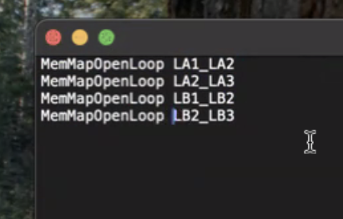

The file should be saved as “stim.txt”
Note: If you intend to perform stimulation across more than one experimental task, you would need to write additional lines for the next task, even if the same pairs are being stimulated. For example:

MemMapOpenLoop LA1_LA2
MemMapOpenLoop LA2_LA3
EFRCourierOpenLoop LA1_LA2
EFRCourierOpenLoop LA2_LA3

4.4.4. Monopolar vs bipolar montages
A monopolar montage combines information regarding the contact name, channel number, and surface area (e.g., “LXB, 10, 5.024”).
A bipolar montage combines successive contacts together (e.g., “LXB1_LXB2 1, 2, 5.024”). This helps elemem account for noise in contiguous channels.
These montages are important, as the task config file references to them.

On the task laptop, generate these montages and experiment configs using these commands:

cd elemem_scripts
conda activate event_creation
mkdir <subj_ID>
cd <subj_ID>
mkdir docs

In this ‘docs’ directory, place the jacksheet.txt, area.txt, and stim.txt files you created.
Then, in terminal, run these commands:

cd .. (go back to the elemem_scripts directory!)
python make_mon.py -s <subj_ID> -d $(pwd)
python generate_configs.py -s <subj_ID> -d $(pwd)

4.5. Identify Bad Channels, seizure onset zone
Consult the physician in charge for the seizure onset zone or check using EPIC (e.g., in the Epilepsy Conference notes for general predictions). To identify bad channels, you can either ask the EEG tech or look yourself in the hardware monitor screen. More detail is given/shown in one-on-one clinical specialist training.

4.6. Checklist to avoid errors / Troubleshooting
- Before starting the experiment
  - Make sure the config file on the task laptop has elemem set to ‘true’ even if running the read only version!!
- Potential Errors
  - “Connection refused” on task computer
    - Make sure elemem is on and task laptop is connected
    - Make sure you clicked ‘start experiment’ on the PC
  - If everything in Elemem is flat
    - Amplifier is probably not working
      - Open the back of the cart and towards the bottom, are there two red lights?
      - If so, close the back of the cart. Go to the front of those two hardware pieces and turn them off (wait 5-10 seconds) turn them on, one at a time.
    - Can also check which electrodes
      - If half of them are flat, probably only one amplifier.
  - 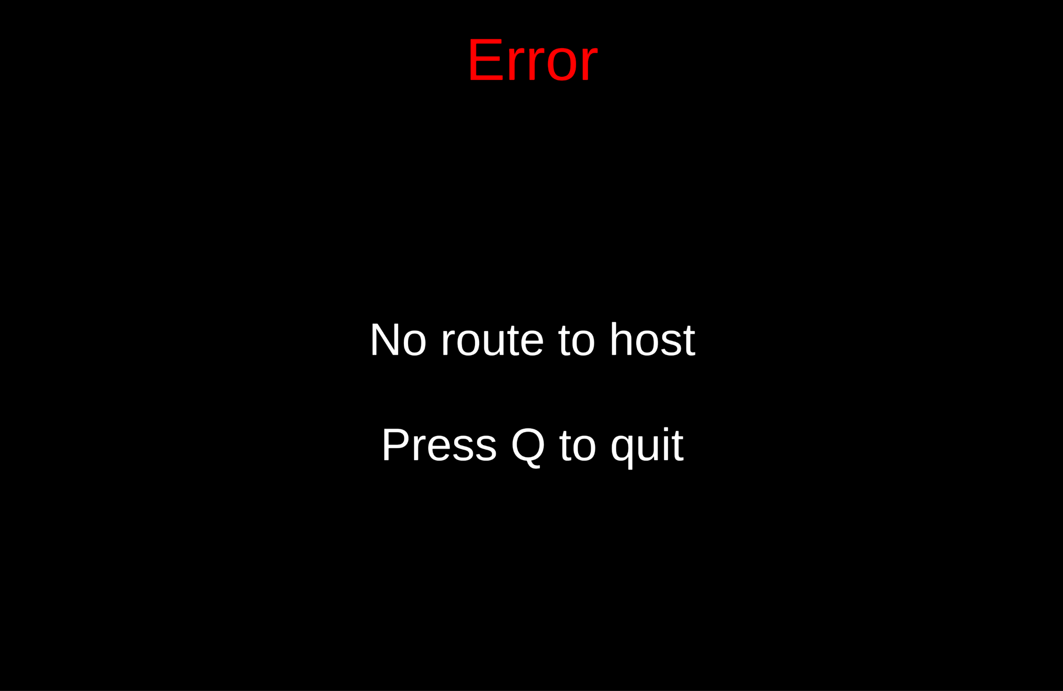
    - if elememOn is ‘true’ but not connected to PC
  - 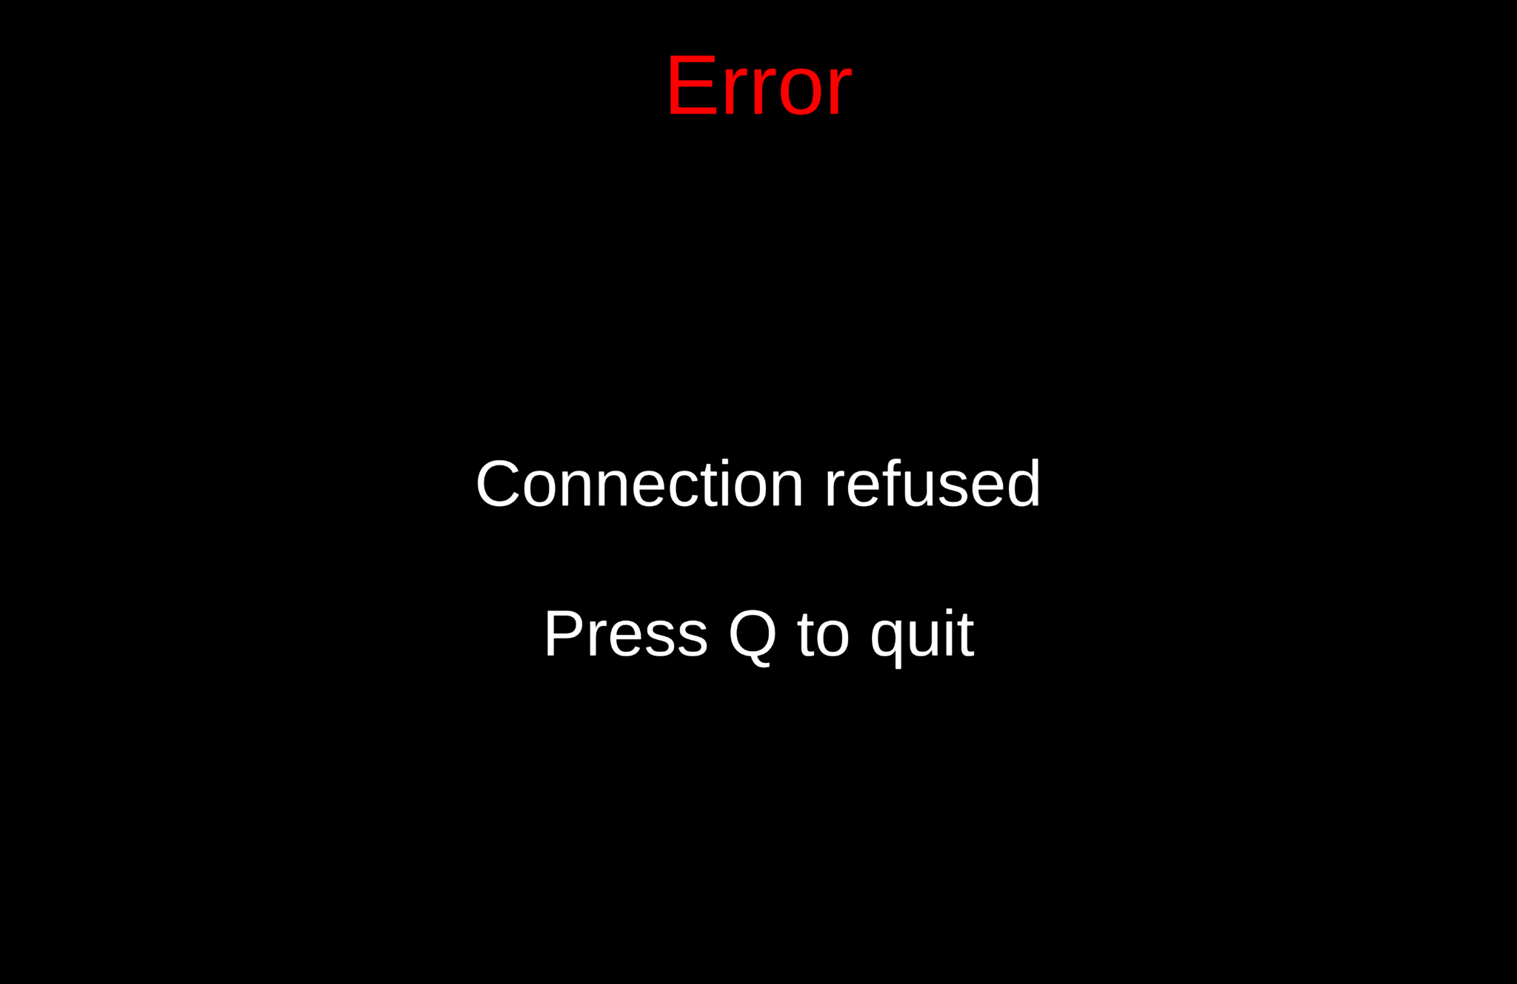
    - make sure to click ‘Start Experiment’ first
    - Or IP address in config file is incorrect
  - 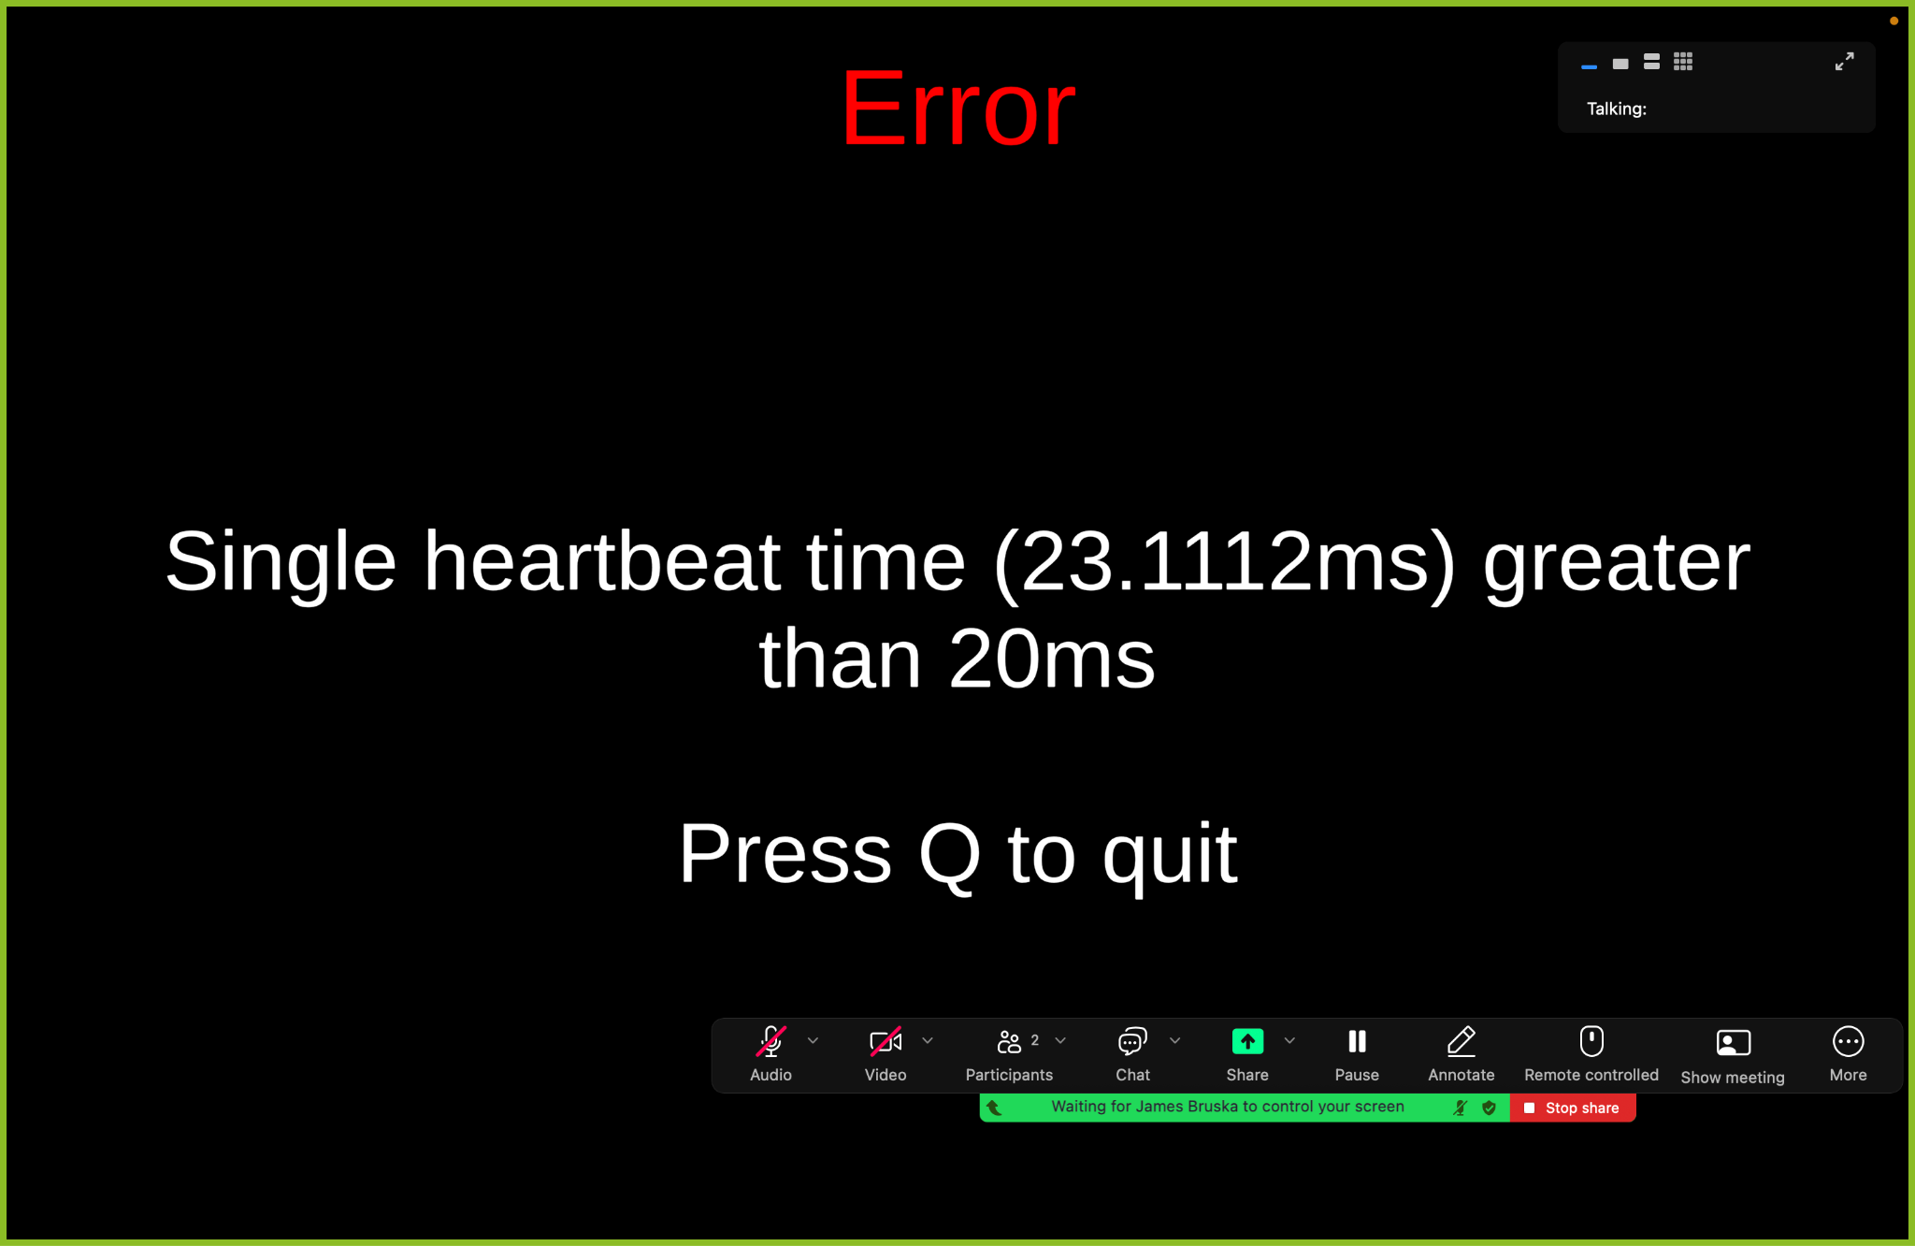 try again

5. Stimulation Safety Testing

Before performing any stimulation experiment with the patient, safety testing is conducted
with a physician to ensure that the designated stimulation parameters do not present any
obvious risk to patient safety.

The first step is obtain the patient’s consent for stimulation. It is vital that the patient be aware
that he or she is receiving stimulation during the experiment.

Next, request the help of a physician for safety testing. The physician may be a resident, fellow,
or attending physician. If he or she is not familiar with our study’s stimulation safety testing,
explain that it is a very quick procedure that takes only about a minute, and explain the
procedures. The physician need not supervise the session but he or she must be available
during the session in case of a seizure or other medical event.

You may wish to have already set up in the patient’s room to avoid wasting the physician’s
time. Once the configuration file has been loaded in Elemem, the stimulation parameter fields
should automatically be populated. Select “Approve Settings” next to the stimulation
parameters that you wish to use; without doing so, stimulation at those parameters will not be
delivered.

When the physician is observing the clinical EEG monitor, announce the stimulation
parameters, including the amplitude, frequency, duration, and site of stimulation. For each set
of stimulation parameters, say “One … two … three … stim.” Do this three times, with a pause
between each iteration to allow for the physician to check for afterdischarges after each time.
Each time, check for the appearance of stimulation artifact on the Elemem and clinical EEG
traces to ensure that stimulation was successfully delivered. For a given set of stimulation
parameters, if afterdischarges fail to appear after three rounds of stimulation delivery, the set
of stimulation parameters is deemed safe.

If the safety testing is successful, you may proceed with the experiment. Otherwise, do not
proceed with stimulation testing without adjusting the stimulation parameters, such as
dropping a stimulation site or lowering the amplitude of stimulation, in consultation with the physician.

6. Saving the Data

6.1. Folder organization

Generally, we save original copies of the data in our remote share drive (HerzLab_Server). We are working on a final directory structure for our computing cluster. But for now, please use the following structure:
HerzLab_Server/
-Subjects/
- M100X/
- data/
- task_laptop
- elemem
- imaging/
- Post_CT_<date>
- Pre_MRI_<date>
- docs/
- area.txt
- jacksheet.txt
- stim.txt
*any other files/configs*

When multiple tasks are run (i.e., not just memory mapping), you can use the following structure:
- M100Y/
- EFRCourierOpenLoop
- data
- imaging
- docs
- MemoryMappingOpenLoop
- data
- imaging
- docs

7. Post-Processing

7.1. Annotations
GENERAL OVERVIEW
Some experiments require patients to make vocal responses (e.g., the Memory Mapping task). These vocal responses are recorded by the testing laptop microphone and saved into sound files (.wav). Before these sessions can be processed and analyzed, a researcher must listen to the .wav files and annotate each word onset (thereby producing an .ann file). Accurately marking the word spoken and the word onset are both very important for ensuring our analyses are correct.

DOWNLOAD PENN TOTAL RECALL (PTR)
Penn Total Recall is a program developed by the lab to facilitate marking the identity and onset of vocal responses. Detailed instructions for annotating can be found in the Annotation Guide.

ANNOTATION GUIDE

7.2. Initial Data Report
Annotations must first be completed in order to run an initial data report for quality assurance.

7.3. Voxtool

8. Additional Information
Cartoon map: a depiction of placement of electrodes on the patient's brain drawn by the clinical team (usually rough drawing, basically showing hemispheric placement and the specific codes used for grids and strips).
How to get images:
- You can use a flashdrive to download pt imaging (included post-surgery CT with lead localization) from the brainlab computer inside the EMU control room. Then, you can upload the imaging to our remote share drive.
- Images can also be requested using the online portal at - https://jefferson.service-now.com/sc_portal

Bad leads information: From the neurologists, testers will need to obtain information regarding which electrodes exhibited seizure activity, e.g. seizure focus activity, ictal spiking, interictal spiking, etc. The easiest way to obtain this information is to ask the EEG techs at Jefferson. This can also often be found in the Teaching folder at Jefferson (Teaching/Invasive EEG/Patients) and in the EMU Reports folder at HUP (EMU Reports/CURRENTYEAR/Implant Reports). Include the bad lead channels (i.e. leads that were in a seizure onset zone, as well as broken leads) in a .txt file called 'bad_leads.txt' so that they can be removed from re-reference (see the bad leads page).

Resection information: After the second surgery of removing the implanted electrodes, obtain from the neurologist whether or not this patient underwent a resection. If so, inquire about which region was removed. This info can also be found on EPIC.

Anonymization: Make sure to anonymize all patient information before leaving the EMU.

9. Additional Resources

- EEG Noise Tutorial: https://github.com/pennmem/eeg_tutorial
- REDCap training: https://upenn.app.box.com/s/2y4rp6xrcyxxjanqao464qb0vwgfnwcq
- RAM_maint training and tips: https://upenn.app.box.com/s/8cfm8m60yj35clblly7fsi0ragjovuv5
- Asana organization: https://upenn.app.box.com/s/n76doboypebcbfaiic17fonqobwwxyg8

Troubleshooting steps
- Elemem connection
  - (see above)
- Controller
  - https://gist.github.com/jackblk/8138827afd986f30cf9d26647e8448e1

